
Supply List for Beginning Iconography
Brushes are your most important purchase. They are also the costliest. Make the best purchase you can afford for brushes, as this will make the greatest impact on technique.

BRUSHES FOR YOU TO PURCHASE
Synthetic Round Brush:
 (1) EITHER, size “2”, or “3” to use as a mixing brush only
Natural Sable Round Brushes (Please Do Not Purchase Synthetic Sable):
(3) “ROUND” natural sable watercolor brushes. (Kolinsky sable is the best)
- Small – (choose 1) either size “1” or “2”
- Medium – (choose 1) either size “3” or “4”  Large - (choose 1) from size “5” or “6”
Soft Synthetic Flat Brush:
(1) Synthetic “flat” brush for applying shellac and varnish. Make sure it is SOFT.
 Size ½”

ADDITIONAL TOOLS FOR YOU TO PURCHASE
- (2) 1 oz dropper bottles
- Compass with scribing point
- 9" x 12" (or similar sized) Multi-Media Pad for notes & painting practice
- (2) 8 oz glass or plastic jars, or brush tub for water/brush cleaning
- Ceramic palette with at least 6 wells for mixing paint (NOT a flat palette)
- #2 pencil
- Red pencil
- Straight edge/ruler
Please see the photo list attached for more detail.

SUPPLIES TO BE PURCHASED IN CLASS
- Pigment scoop (we have the right size & type of scoops available for $2)
- GOLD LEAF: You will be using 23.75 Manetti gold leaf to gild your icon. The market-place price for gold fluctuates and the minimum quantity you can buy is a book of 25 leaves for ~$100 per book. Because you will need only a few leaves, we will buy the gold in bulk and sell it in class as you require at $5.00 per sheet, the current price of gold.
WE PROVIDE DRY PIGMENTS:
We have prepared student Pigment Kits using natural earth and ground mineral pigments imported from Zecchi’s in Florence, Italy – a world class pigment shop that has served the masters since the Renaissance. We also provide a step by step instruction manual, gessoed wood icon panel, a black and white cartoon of the icon image, transfer paper and vellum.
There are other one-time use supplies that we’ll provide for your use in class including sandpaper, goldwork scissors, goldwork make-up brushes, scribers, scalpels, frog tape, drafting tape, shellac & brush cleaner.
You will be using dry powder pigments, alcohol solvents and will be sanding your icon. If you are sensitive to dry pigments, solvents, or dust, please obtain advice from your healthcare provider and/or wear a mask.

Visual Examples & Buy Links
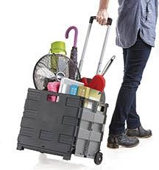

STORAGE TROLLEY
You will want to come up with a convenient method of toting your supplies to and from class. Some students use this type of collapsible cart to avoid lifting and carrying their art supplies. (Not required, simply helpful)

Amazon Link

STORAGE BOX FOR YOUR ICON
The icon you will write is 8” x 10” x 2”. You will want to choose a box to safely transport your icon to and from class. Here are some options:

Link to Michael’s Craft Store

NATURAL SABLE WATERCOLOR BRUSHES (ROUND)

DaVinci offers an affordably priced set of natural Harbin Kolinsky Sable brushes in sizes we use.

Please purchase SHORT HANDLE brushes, optimally, FULL BELLY ROUND or ROUND.

At a minimum, you will need three brushes:
- A small one in a size 1 or 2
- A medium one in size 3 or 4
- A large one in size 5, or 6

Link to a more affordable option on Amazon: Harbin Kolinsky
Link to a premium option on Amazon: Davinci Maestro Kolinsky

Please do not purchase “synthetic sable” as these are too stiff for our painting technique.

DaVinci is a premium brand that comes with a higher price tag. You may purchase any “natural” sable brush, but please avoid the misleading label “synthetic natural sable.”

PURCHASE OPTIONS FOR INDIVIDUAL BRUSHES

If you choose to purchase individual brushes instead of a set, look for “rounds,”or even better, Full Belly Rounds.

Blick Art Materials
Jerry’s Artarama

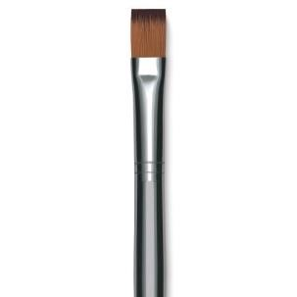
FLAT SYNTHETIC BRUSH FOR APPLYING GILDING SIZE & SHELLAC

You will need 1 soft, synthetic ½” flat brush for applying gilding size & shellac. Long handled brushes are cheaper, but also unwieldy. Select the short handle brush. Suggested link to Blick Art Materials.

You can also find this type of inexpensive brush at a craft store like Michael’s.

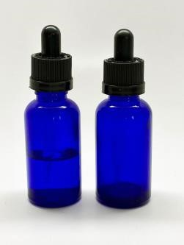

2 DROPPER BOTTLES OF IDENTICAL SIZE

The bottle color doesn’t matter. You simply need 2 identical dropper bottles: (1) for water & (1) egg emulsion. Amazon sells a 2 pack of amber bottles for around $5.

Amazon Buy Link

MULTI-MEDIA SKETCHPAD (9” x 12”)

Blick Art Materials offers an extensive variety of multi-media pads. We specify “multi-media” because the paper is thicker, allowing it to be used for painting exercises without bleeding through to the rest of the pad. Bristol paper is even better, but more expensive. When selecting from the many choices, select a multi-media pad in your price range with the highest paper weight. A nice choice is Canson at 98lbs, for example.

COMPASS (Nice to Have) – we have extras in class

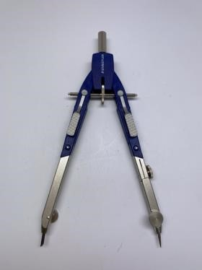
A compass can be expensive; we have a few extras in class. Purchase one according to your budget that has a sharp scribing point as we use this for making the halo. This suggested option has spring-loaded arms (gray pads beneath the adjustment bar) which make it easy to pull open to the right distance for large adjustment, while the wheel makes minor adjustments.

We have some extras in class, but if you plan to continue, a compass is essential.

Suggested Compass on Amazon

CERAMIC PALETTE
Please purchase ceramic. Plastic stains easily, embedding pigment into the wells that could inadvertently affect your pigment mix. Make sure to purchase a palette with deep wells to hold more liquid and not a flat palette or one with tiny wells for watercolor.

Suggested Buy Link for the 7 well flower palette

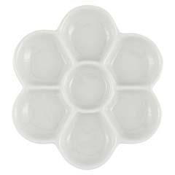
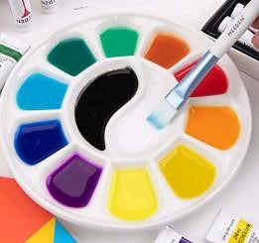
Suggested Amazon Buy Link for a 12 well palette

(2) 8 oz. WATER JARS FOR RINSING YOUR BRUSHES

Any type of container that holds at least 8 oz of water will work. Repurposed mason jars, jam jars or plastic tubs will work great for rinsing your brushes.

(Remember that glass is nice, but heavier and you’ll be carrying your supplies.)

Here is a brush tub at Amazon. You can also find a similar style at Michael’s.

