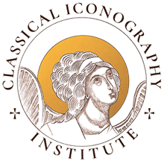
Supply List for Sacred Letters – Iconographic Calligraphy
Our instructor has specified the following art supplies for the course. This list contains buy links that match her specifications. You do not need to purchase these items from the linked vendors, but please purchase the same brands as specified.

- (1) 6mm Pilot parallel pen with a set of ink cartridges. Amazon buy link for 6mm.
- (1) Flat, synthetic, very stiff short bristle brush (not long bristle) with a short handle.
Suggested brands – (you only need 1)
Princeton select chisel blender #6 (Blick)
Princeton Series 6500 Aspen Synthetic Brush - Short Handle, Bright, Size 2 (Blick), or
Firenze Artist’s Loft Bright Flat brush size 2. (short handle is more manageable) (Blick) Call Blick in Portland or Beaverton for in-store availability.
- (1) Round brush - Pentel Japan Aquash Waterbrush Pen, medium. Available on Amazon.
- (1) Small ruler – your choice
- (1) Eraser – kneaded eraser (Blick) or stick eraser (Blick)
- (2) Pencils of different colored pencils - brand and colors not important
- (1) black pencil

The Institute has large rulers and red colored pencils to loan. Each student will receive a special 120 gms heavy graph paper notebook for practice, and a step-by-step instruction manual developed by our instructor, based on her calligraphy training in Russia.

