

Supply List for Iconography

Brushes are your most important purchase. They are also the costliest. Make the best purchase you can afford for brushes, as this will make the greatest impact on technique.

**BRUSHES FOR YOU TO PURCHASE**

**Synthetic Round Brush**: SHORT HANDLE

* (1) EITHER, size “2”, or “3” to use ***as a mixing brush only***

**Natural Sable Round Brushes (Please Do Not Purchase Synthetic Sable)**: SHORT HANDLE

(3) “ROUND” natural sable watercolor brushes. (Kolinsky sable is the best)

□ Small – (choose 1) either size “1” or “2”

□ Medium – (choose 1) either size “3” or “4”

□ Large - (choose 1) from size “5” or “6”

**Soft Synthetic Flat Brush**: SHORT HANDLE

(1) Synthetic “flat” brush for applying shellac and varnish. Make sure it is SOFT.

* Size ½”

**TOOLS FOR YOU TO PURCHASE**

* (2) 1 oz dropper bottles
* Compass with scribing point
* 9" x 12" (or similar sized) Multi-Media Pad for notes & painting practice **(Level II & III only)**
* 5”x7” (or similar sized) Water Color Pad for painting practice **(Level I only)**
* (2) 8 oz glass or plastic jars, or brush tub for water/brush cleaning
* *Ceramic* palette with at least 6 wells for mixing paint (NOT a flat or watercolor palette) or small mixing dishes

**WE PROVIDE**

**DRY PIGMENTS | 23.75 KT GOLD LEAF | ICON BOARD:**

We have prepared student Pigment Kits using natural earth and ground mineral pigments imported from Zecchi’s in Florence, Italy – a world class pigment shop that has served the masters since the Renaissance. We also provide a step by step instruction manual, gessoed wood icon panel, a black and white cartoon of the icon image, transfer paper and vellum.

We supply Manetti 23.75kt Gold Transfer Leaf from Florence, Italy for you to gild your icon.

We provide a gessoed icon board made by the Institute.

There are other one-time use supplies that we’ll provide for your use in class including sandpaper, goldwork scissors, goldwork make-up brushes, scribers, scalpels, frog tape, drafting tape, shellac & brush cleaner.

**You will be using dry powder pigments, alcohol solvents and will be sanding your icon. If you are sensitive to dry pigments, solvents, or dust, please obtain advice from your healthcare provider and/or wear a mask.**

**Visual Examples of What to Purchase**

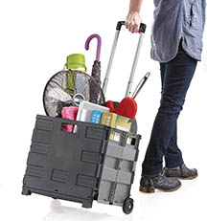**STORAGE TROLLEY**

You will want to come up with a convenient method of toting your supplies to and from class. Some students use this type of collapsible cart to avoid lifting and carrying their art supplies. (Not required, simply helpful)

**STORAGE BOX FOR YOUR ICON**

The icon you will write is 8” x 10” x 2”. Bring a box to safely transport your icon to and from class. Michael’s and other craft stores often carry clear plastic cases in their scrapbooking department. This snap top case is available for under $5 at Hobby Lobby.

**NATURAL SABLE WATERCOLOR BRUSHES (ROUND)**

DaVinci offers an affordably priced set of natural Harbin Kolinsky Sable brushes in sizes we use (0, 2, 4, 6 ) for under $40. Here is an Amazon Buy link: [DaVinci Harbin Kolinsky Sable Brush Set](https://www.amazon.com/Vinci-Watercolor-Brush-Set-5547A2/dp/B09G529LJ4/ref=sr_1_2?crid=3DK4VFWPGQW3I&dib=eyJ2IjoiMSJ9.f8xd5w0rNQDbeAVKBgLMHQOTke5rIYTCRIh7ceCO9V65axfWjHsh65PTYZNfFlSqKgi2m5sfSh2sOZBo5W7oo9M63_jHvxes2AuFjyQud9HZu-moDK4SgNCQk1-Txt9E1pMuUWZFzG_BKurq5ZFhVNtRaE45GXFf86pdyLiJajRHVTy7_e8179E9O2w_YjSU0wxYL8AnnF_BYLDFGGTTpzMiISAX58xwpQU0yD5oSMNyNwtKJ4kn017uH6_8gHe2nRL-OmEZ0CHcqgLj2uuIXpytAq5tNz_IPxt8_sibqUQ.ExNj-wjTE6kwV3jWPjlQp0sbHDzFbfBjyNkAeXXJLYM&dib_tag=se&keywords=da+vinci+harbin+kolinsky&qid=1727734330&sprefix=davinci+harbin%2Caps%2C228&sr=8-2).

Please purchase **SHORT HANDLE** brushes, optimally, FULL BELLY ROUND or ROUND.

At a minimum, **you will need three brushes**:

* A small one in a size 1 or 2
* A medium one in size 3 or 4
* A large one in size 5, or 6

Link to a premium option on Amazon: [Davinci Maestro Kolinsky](https://www.amazon.com/Vinci-Brushes-Watercolor-Set-5546a2/dp/B09G499LJT/ref=sr_1_10?crid=1A2P5OH0Y47FA&keywords=davinci+maestro+kolinsky+sable+watercolor+brushes&qid=1705351115&sprefix=davinci+maestro+kolinsky+sable+watercolor+brushes%2Caps%2C205&sr=8-10&ufe=app_do%3Aamzn1.fos.006c50ae-5d4c-4777-9bc0-4513d670b6bc)

***Please do not purchase “synthetic sable” as these are too stiff for our painting technique and will lead to frustrating holes in your icon.***

**PURCHASE OPTIONS FOR INDIVIDUAL BRUSHES**

If you choose to purchase individual brushes instead of a set, look for short handle “rounds,”or even better, Full Belly Rounds.

[Blick Art Materials](https://www.dickblick.com/products/da-vinci-maestro-kolinsky-brushes/?fromSearch=%2Fsearch%2F%3Fsearchword%3Dkolinsky%20sable)

[Jerry’s Artarama](https://www.jerrysartarama.com/da-vinci-maestro-kolinsky-red-sable-watercolor-brushes)

**FLAT SYNTHETIC BRUSH FOR APPLYING GILDING SIZE & SHELLAC**

You will need 1 soft, synthetic ½” flat brush for applying gilding size & shellac. Long handled brushes are cheaper, but also unwieldy. **Select the short handle brush.**

[Suggested link to Blick Art Materials](https://www.dickblick.com/products/royal-langnickel-zen-all-media-brushes/?clickTracking=true&wmcp=pla&wmcid=items&wmckw=09149-6012&gclid=Cj0KCQjwtsv7BRCmARIsANu-CQcjeZGsrjI_zforWYjSuxnwl28Qo_IMYXFhOWtHRMssW10oIlo1db4aArkLEALw_wcB).

***You can also find this type of inexpensive brush at a craft store like Michael’s.***

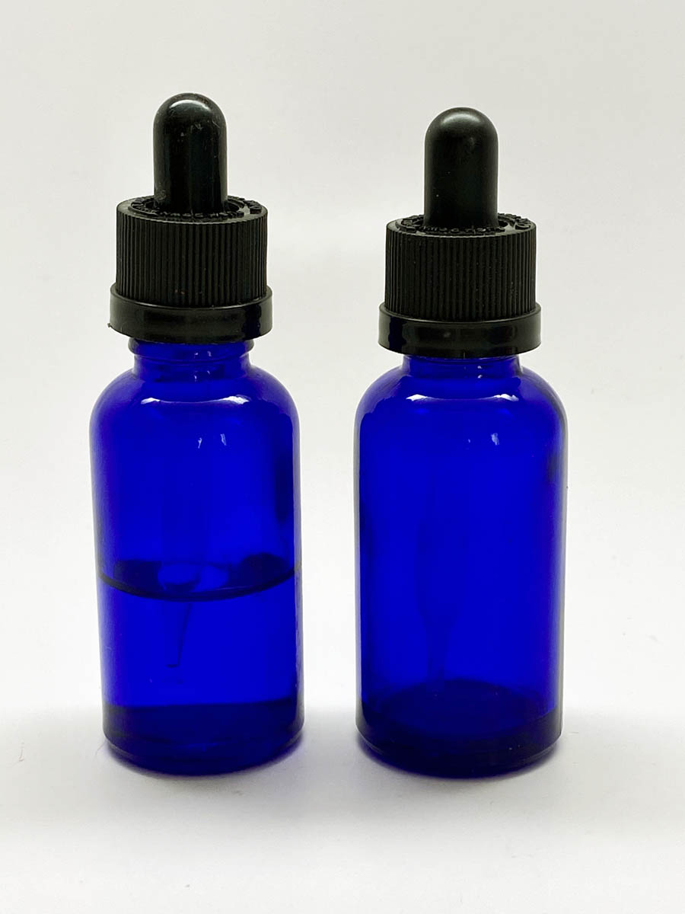

**2 DROPPER BOTTLES OF IDENTICAL SIZE**

The bottle color doesn’t matter. You simply need 2 identical dropper bottles: (1) for water & (1) egg emulsion. Amazon sells a 2 pack of amber bottles for around $5.

**[Amazon Buy Link](https://smile.amazon.com/DropperStop-Dropper-Bottles-Tapered-Droppers/dp/B073SHXGT5/ref=sr_1_4?crid=3RZLFXPHW2XFF&keywords=1+oz+dropper+bottles&qid=1654828673&sprefix=1+oz+dropper+bottles%2Caps%2C141&sr=8-4)**

**LEVEL II & III - MULTI-MEDIA SKETCHPAD (9” x 12”)**

Blick Art Materials offers an extensive variety of multi-media pads. We specify “multi-media” because the paper is thicker, allowing it to be used for painting exercises without bleeding through to the rest of the pad. Bristol paper is even better, but more expensive. When selecting from the many choices, select a multi-media pad in your price range with the highest paper weight. A nice choice is Canson at 98lbs, for example.

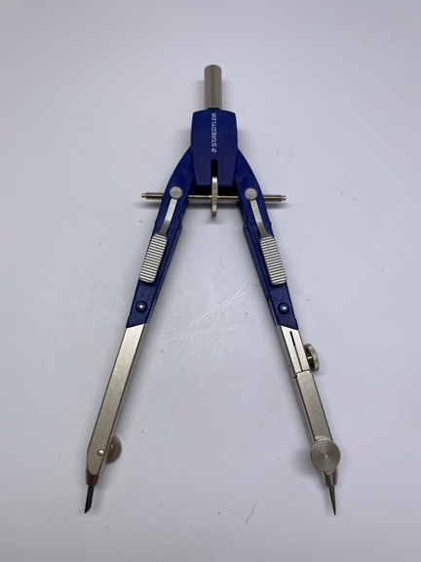**COMPASS (Nice to Have) – we have extras in class**

A compass can be expensive; we have a few extras in class. Purchase one according to your budget that has a sharp scribing point as we use this for making the halo. This suggested option has spring-loaded arms (gray pads beneath the adjustment bar) which make it easy to pull open to the right distance for large adjustment, while the wheel makes minor adjustments.

We have some extras in class, but if you plan to continue, a compass is essential.

[**Suggested Compass on Amazon**](https://www.amazon.com/Staedtler-Comfort-Setting-552-01/dp/B001F9P8LQ?ref_=ast_sto_dp&th=1&psc=1)

**CERAMIC PALETTE**

*Please purchase ceramic*. Plastic stains easily, embedding pigment into the wells that could affect your pigment mix. Purchase a palette with deep wells to hold more liquid and *not a flat palette or one with tiny wells for watercolor*.

**

You can also use small ceramic condiment dishes.

[**Link to Condiment Dishes**](https://www.amazon.com/DRAONGYE-Ceramic-Condiment-Ketchup-Vinegar/dp/B0BS1F5DC4/ref=sr_1_6?crid=X11A66F7M3RP&dib=eyJ2IjoiMSJ9.9sOkqyhhNVV8ZbiXQoEyX1DbmbMw-NZgppTA5eL3VTCA1fSwKfL3V1wTsqZ4-opdZPfpwHUgof76Zi9P8Ft9RYrPoyZoDTdUALF-Ak4Zn31l5WuNRbNN3lDlayAjz_fa5HNwXyJga-ijgJyoUNMM9qINmajq7O1vg-ZqcPpdE6GTcEdJn1TqC3bX4SPfYZwYvn5LPAfqIi2lPyKpyu6KzU7VTy04Pt7pTUTc0s0DB2KGT0WwXxN8s8LNbyKI6PPhhj8RvtEtkhJAotJO-DN9G0j0JdYJbxAktZBEoPOCI4Y.Dv84tfJ773cI6UtpbEUm6oPVXnmUtLQYNC0wb8yJ8b0&dib_tag=se&keywords=ceramic%2Bcondiment%2Bbowls%2B3%2Boz&qid=1727736048&sprefix=ceramic%2Bcondiment%2Bbowls%2B3%2Boz%2Caps%2C213&sr=8-6&th=1)

**(2) 8 oz. WATER JARS FOR RINSING YOUR BRUSHES**

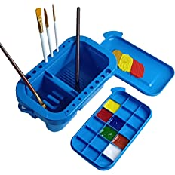

Any type of container that holds at least 8 oz of water will work. Repurposed mason jars, jam jars or plastic tubs will work great for rinsing your brushes.

(Remember that glass is nice, but heavier and you’ll be carrying your supplies.)

[Here is a brush tub at Amazon](https://www.amazon.com/dp/B0BKZBMDG2/ref=sspa_dk_detail_0?psc=1&pd_rd_i=B0BKZBMDG2&pd_rd_w=CRILl&content-id=amzn1.sym.88097cb9-5064-44ef-891b-abfacbc1c44b&pf_rd_p=88097cb9-5064-44ef-891b-abfacbc1c44b&pf_rd_r=NBTX3DK6D9ZT7Z7CBS2M&pd_rd_wg=NGIWv&pd_rd_r=10d5813b-3b75-4226-9238-0fccaed71fa9&s=home-garden&sp_csd=d2lkZ2V0TmFtZT1zcF9kZXRhaWw). You can also find a similar style at Michael’s.